Table of Contents
1.0 OBJECTIVE 2
2.0 SCOPE 2
3.0 RESPONSIBILITIES 2
3.1 Group Leader 2
3.2 Project Leader 2
3.3 Laboratory Room In-Charge/Key Owner 2
3.4 All Staff and Visitors 2
4.0 DEFINITIONS 3
5.0 REFERENCES 4
6.0 SAMPLE REQUIREMENTS 4
7.0 REAGENTS 5
7.1 Quantification Standards 5
8.0 CONSUMABLES 6
9.0 EQUIPMENT 6
10.0 WORK SAFETY 7
11.0 TEST WORKFLOW and PROCEDURE 7
11.1 Environmental Sample Submission 8
11.2 Sample Receipt and Test Document Setup 9
11.3 Bacterial Isolation 10
11.4 Viability Test Treatment 11
11.5 Nucleic Acids Extraction 11
11.6 Target Detection 11
11.7 Data Analysis 14
11.8 Result interpretation 14
12.0 REVISION HISTORY 18
13.0 APPENDIX 18

- OBJECTIVE
This protocol describes the procedures of DNA extraction from water samples and assess the presence of Legionella and E.coli bacteria via qPCR using Legionella and E. coli test Kit. In addition this protocol also defines the procedures for receiving water samples, storage of samples, safe handling of samples, proper disposal of biohazard waste and qPCR data analysis for the quantification of detected Legionella and E.coli bacteria. All work to be conducted in compliance to ISO13485 regulations and MOH Guidelines.
- SCOPE
This procedure applies to Center for Genome Diagnostics under A*STAR, Genome Institute of Singapore.
- RESPONSIBILITIES
  - Group Leader
He/she shall ensure that all resources are available, staff is trained to the requirements stated before conducting laboratory work in the designated laboratories.
  - Project Leader
The Project Leader is responsible to coordinate and liaise all incoming and/or outgoing project related samples with third parties and ensure that the project team and visitors (if any) comply with the requirements stated in this document. He/She is the key contact person to monitor and record the usage of the samples. He/She should ensure that all operators are well trained and competent.
  - Laboratory Room In-Charge/Key Owner
The Laboratory Room In-Charge shall maintain storage facilities to the requirements stated in this document. He/She is also responsible to manage the Sample Storage Keys, and document required records accordingly.

  - All Staff and Visitors
It is the responsibility of all staff and visitors to follow requirements stated in this document. He/she is responsible for receiving and verifying all and only samples intended for his/her project team when required, notifying the Project Manager and/or Project Leader. They should perform experiments and data analysis based on the procedures stated in this SOP.

- DEFINITIONS

Term / Acronym | Description
A*STAR | Agency for Science, Technology and Research.
CGD | Centre for Genome Diagnostics
Consumable | Products that consumers use recurrently.
DNA | Deoxyribonucleic acid
ESSF | Environmental Sample Submission Form
FAM | Fluorescein amidites
GIS | Genome Institute of Singapore
HEX | Hexachloro-fluorescein
ID | Identification/Identity
LTD | Laboratory of Translational Diagnostics
L5 | Level 5 (GIS 5th floor)
L7 | Level 7 (GIS 7th floor)
Material | Refers to reagents and consumables, equipment and biological samples that is required for its intended use for experiment.
mg | Milligram
min | Minute(s)
mL | Milliliter
MM | Master Mix
NC | Negative Control
NTC | No template control
PCR | Polymerase chain reaction
Positive Control (PC) | A mixture of three DNA templates
PPE | Personnel Protective Equipment
sec | Second(s)
SOP | Standard Operating Procedure
STD | Standard. E.g. Standard for HEX Channel
TA | Template Addition
Texas Red | sulforhodamine 101 acid chloride
Ultraviolet (UV) sterilization | It is a disinfection method that uses short-wavelength ultraviolet (UV-C) light to kill or inactivate microorganisms by destroying nucleic acids and disrupting their DNA, leaving them unable to perform vital cellular functions.
µL | Microliter

- REFERENCES
• SOP-TR1-QMS-003 Laboratory Workflow
• SOP-TR1-QMS-016 Sample Extraction and Quantification Guideline
• QR-TR1-QMS-014 F02 Sample Management Log
• QR-TR1-QMS-014 F03 Sample Tracking Checklist
• QR-TR1-QMS-014 F04 Sample Tracking Log
• QR-GIS-QMS-011 F01 Customer Satisfaction Form
• QR-GIS-QMS-011 F02 Customer Satisfaction Log
- QR-GIS-QMS-014 F02 Deviation Report

- QR-GIS-QMS-014 F04 Nonconformance Report

- QR-GIS-QMS-015 F01 Corrective Action Report

- QR-GIS-QMS-015 F02 Preventive Action Report

- Laboratory Biosafety Resources Related to SARS-CoV-2/COVID-19 Virus Samples/Materials, MOH, 20 Nov 2020
- SAMPLE REQUIREMENTS
Incoming samples shall be provided as water samples collected using sample collection bottle/ bag. Samples delivered must pass incoming inspection criteria. Failure to do so may result in sample rejection. Criteria include:
- Visual inspection of sample integrity
  - Intact container
  - Sample present in container
- Sample transport conditions
  - Room Temperature
- Sample labels
  - Sample labelling on container matches with the respective Biological Sample Delivery and Receipt Form
  - At least 2 matching unique identifiers (such as sending source, external sample identifier number, etc.)
- Biological Sample Delivery and Receipt Form
  - The form subject ID should match those on the sample collection bottle

- REAGENTS
Reagents | Components  (if any) | Company | Catalog Number | Storage Location
E Lysis Buffer | NA | CGD/ GIS | Varies | MM Room
A1 Elution buffer | NA | CGD/ GIS | Varies | MM Room
Legionella PCR Kit | PCR reaction buffer | CGD/ GIS | Varies | MM Room
Legionella PCR Kit | Primers-Probes Mix | CGD/ GIS | Varies | MM Room

  - Quantification Standards

Reference DNA | Concentration (copies/µL) | Catalog/ Ref Number | Lot Number | Date of Manufacture | Expiry Date
 |  |  |  | (DDMMMYY) | (DDMMMYY)
HEX  Standard 1 | TBC | TBC | TBC | TBC | TBC
HEX  Standard 2 | TBC | TBC | TBC | TBC | TBC
HEX  Standard 3 | TBC | TBC | TBC | TBC | TBC
HEX  Standard 4 | TBC | TBC | TBC | TBC | TBC
FAM  Standard 1 | TBC | TBC | TBC | TBC | TBC
FAM  Standard 2 | TBC | TBC | TBC | TBC | TBC
FAM  Standard 3 | TBC | TBC | TBC | TBC | TBC
FAM  Standard 4 | TBC | TBC | TBC | TBC | TBC
Texas Red  Standard 1 | TBC | TBC | TBC | TBC | TBC
Texas Red  Standard 2 | TBC | TBC | TBC | TBC | TBC
Texas Red  Standard 3 | TBC | TBC | TBC | TBC | TBC
Texas Red  Standard 4 | TBC | TBC | TBC | TBC | TBC
- CONSUMABLES
Consumables | Company | Catalog Number
Hard-shell 96-well PCR plate | Bio-Rad | HSP9601
Pipette tips | ThermoFisher Scientific/Rainin | Various
PCR Plate Seals | Bio-Rad | MSB1001
1.5 mL DNA LoBind Micro tube | Eppendorf | 0030 108.051
Serological Pipettes | Corning/VWR | Various

- EQUIPMENT
Equipment | Serial No. / GIS Asset Number | Location
4°C Refrigerator, EKObasic Sample Prep | 410000006394 | Sample Prep Room
BSC, Thermo Scientific 1300 Series A2 Class II | 410000006368 | Sample Prep Room
Pipette - 1000 µL | Z62758L | Sample Prep Room
Pipette - 200 µL | X53249D | Sample Prep Room
Pipette - 20 µL | W64416E | Sample Prep Room
Pipette - 10 µL | W56221H | Sample Prep Room
Heat block, Thermomixer Comfort with shaking | 410000005616 | Sample Prep Room
Vortex Mixer, Corning 6777 | S2030218 | Sample Prep Room
Electronic Pipette Gun | NA | Sample Prep Room
BioRad CFX96 | BR200728 | Instrument Room
Microplate Centrifuge | TT-E14-1132 | Instrument Room
Picofuge | NA | Master Mix Room
Picofuge | NA | Template Addition Room
PCR Cabinets | 419000002856 | Master Mix Room
PCR Cabinets | 419000003199 | Template Addition Room
4°C Fridges | 410000006285 | Master Mix Room
4°C Fridges | 410000006283 | Template Addition Room
-20°C Freezers | 410000025985 | Master Mix Room
-20°C Freezers | 410000006284 | Template Addition Room
Pipette - 1000 µL | KJ09437 | Master Mix Room (MM)
Pipette - 200 µL | C006993455 | Master Mix Room (MM)
Pipette - 20 µL | HH93920 | Master Mix Room (MM)
Pipette - 10 µL | KJ08190 | Master Mix Room (MM)
Pipette - 1000 µL | C006992352 | Template Addition Room (TA)
Pipette - 200 µL | C006993052 | Template Addition Room (TA)
Pipette - 20 µL | OZ00190 | Template Addition Room (TA)
Pipette - 10 µL | C006992852 | Template Addition Room (TA)

- WORK SAFETY
All environmental samples are to be considered as hazardous. The required PPE shall be dependent on the work performed in each venue, according to the table below:

Venue | Minimum PPE required | Types of work done
GIS Lobby, Level 1 | NA | Collection of samples from client
Sample preparation room, Level 5 | - Lab coat  - Gloves  - Safety Goggles  - 3-ply mask (Disposable) | Handling water samples  Viability test treatment  Nucleic Acids Extraction
Master Mix Room, Level 7  Template Addition Room, Level 7  Instrument Room, Level 7 | - Lab coat  - Gloves  - Safety Goggles | qPCR detection assay setup
Office | NA | Data analysis & Quantification

During the handling of samples, there is still a risk that spills and splashes might occur. Any suspected work surfaces and equipment that come into contact with unextracted environmental samples must be decontaminated immediately with appropriate disinfectants such as 70% ethanol solution.
- TEST WORKFLOW and PROCEDURE

The test workflow is shown below, and tracked with the worksheets:
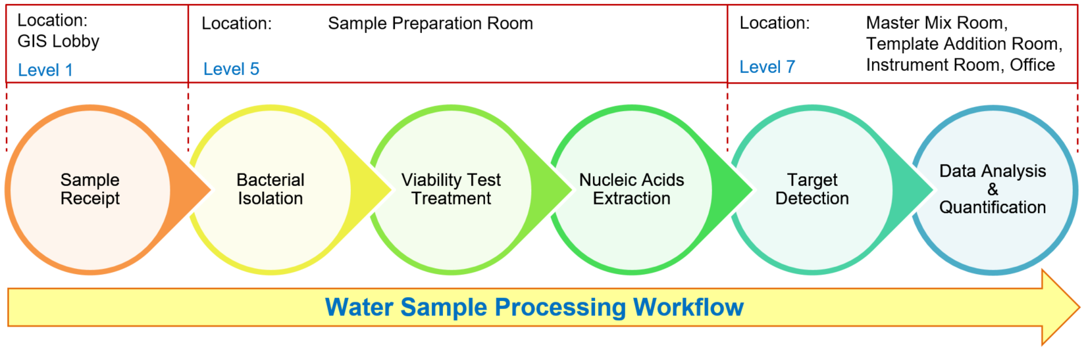

  - Environmental Sample Submission
Environmental samples submission form (ESSF) () are to be filled up and submitted by the client company to ensure proper documentation. Below is a representation of the ESSF:
Client Company are to fill the necessary information for Section A and B prior submission to CGD for sample submission and processing.
  - Sample Receipt and Test Document Setup
- Meet the delivery personnel at the designated area in GIS Level 1 Lobby and receive the sample. All relevant forms (e.g. Sample Tracking sheet, Shipment sheet) and receipts will be used as proof of delivery.
- The samples should be collected based on SOP_Sample collection Guideline.
- Fill the courier log and get delivery personnel’s signature. Transfer samples to designated lab dedicated for water sample handling (Sample preparation room at level 5).
- Don appropriate PPE to enter the sample preparation room.
- Place the sample collection bottle/ bag into the BSC hood. Disinfect the sample collection bottle/ bag with 70% ethanol solution.
- Perform an initial visual inspection. This involves ensuring that the sample collection bottle/ bag is still intact, and the labelling on the sample collection bottle/ bag.
- Isolate any bottle/bag with leakages by placing these samples and their associated bags in a fresh secondary containment (for example, Biohazard bags).
- If a spill has occurred and liquid is in contact with any PPE and/or work surfaces, immediately perform decontamination with 70% alcohol and wipe the spill.
- Proceed immediately to the next step.

    - Acceptance Criteria Check
- Perform visual inspection on the delivered documents and items in the BSC hood, ensuring that all Sample Acceptance Criteria (box below) of “Section C: Receipt of Sample(s)” of ESSF are met.
Sample Acceptance Criteria
Environmental Sample Submission Form (ESSF) has all compulsory required fields filled, AND The Sample collection bottle/bag must pass visual inspection, which includes ALL the criteria below:
(1) Sample Shipped in Provided Sample collection bottle/ bag
(2) Sample Collection bottle/bag are Intact, e.g. capped, without cracks, without leaks
(3) Sample Collection bottle/bag contains fluid
(4) The Labelled Sample ID matches the ID in ESSF
(5) The Overall Visual Inspection pass.
- Based on the outcome of visual inspection, fill up the Section C. RECEIPT-Recipient to Complete of the ESSF.
- Record the Sample information provided in the ESSF in the Sample Database(excel).
- Tracking of samples including aliquots, from the time of sample receipt or once the sample status is known in the Sample Database (excel).
- Samples shall be stored at 4°C Fridge for a maximum storage period of 7 days from the date of sampling before disposal.
- Dispose of the samples in accordance with regulatory requirements for disposal of biological waste materials; and notify MOH Biosafety Branch in the event of any of the following:
Occurrence of any adverse incident related to the handling of the samples.
7. Create a folder in the Service Folder and label it as “ESSF-YYYYMM-NNN” with YYYYMM corresponding to the Year and Month of sample submission, & NNN corresponding to the number of ESSF received within the month.
8. Transfer and the SOP Test Form into the folder and record all the necessary information throughout the test workflow into this document.
9. Verifiy and fill up the SOP Test Form’s “1) Equipment” and “2) Sample_Info” sheets before processing the sample.
10. Process the sample according to the SOP Test Form’s “3) Extraction” and “4)TargetDetection” sheet.
11. Ensure that there are sufficient amount of reagent (E lysis buffer & A1 Elution buffer) available by referencing with the required volume calculated of each reagents listed in the SOP Test Form’s “Extraction” Sheet. Follow the protocol listed for the 3 steps of extraction: Bacterial Isolation, Viability Test Treatment, & Nucleic Acids Extraction.
  - Bacterial Isolation
- Clean the workstation of the BSC using 70% ethanol before and after use.
- Carefully open the sample collection bottle/bag and transfer 50 mL of water sample into a 50 mL falcon tube with serological pipette and pipette gun.
- Centrifuge the sample-containing 50 mL falcon tubes at 3,500 rpm for 10 minutes.
- Carefully remove the falcon tubes from the centrifuge and place them onto a rack
- Carefully transfer and discard the supernatant (~49.9 mL) of the centrifuged samples from the falcon tube until it remains 100 µL of volume.
- Carefully transfer the remaining 100 µL into a 1.5 mL tube for subsequent testing.
  - Viability Test Treatment
- Due to the light-sensitive nature of the PMAxx™, all of the experimental steps should be carried in dark until the completion of light treatment.
- Working in the dark, add 1.25 µL of PMAxx™ stock solution into 100 µL of the isolated bacterial sample to achieve a final concentration of 25uM.
- Add 25 µL of PMA Enhancer for Gram Negative Bacteria (5X) will be added into the sample to achieve its working concentration.
- Vortex the sample briefly and Incubate the tubes in the dark for 15 minutes at room temperature.
- Expose the samples to light treatment (465-475 nm) for 10 minutes to cross-link PMAxx™ to DNA.
  - Nucleic Acids Extraction
- Add 700 µL of E1 lysis buffer into the light-treated sample tube and vortex briefly.
- Centrifuge the samples briefly to ensure all the liquid has settled to the bottom of the tube.
- Heat the sample tubes at 80°C for 10 minutes.
- Centrifuge the samples tubes at 15,000 rpm for 10 minutes.
- Carefully remove and discard the supernatant without disturbing the pellet. The remaining volume should be 5 µL or lesser.
- Add 50 µL of A1 elution buffer to reconstitute the extracted DNA.
- If the Sample is not to be processed immediately, store at -20°C freezer for future uses.
  - Target Detection

    - Preparation of Legionella Assay PCR Kit
- Refer to SOP Test Form’s “4) TargetDetection” sheet for detection assay setup and qPCR detection.
- At Master Mix room, clean the workstation of the PCR hood with soap water and then MiliQ water before use with M-fold towel.

- Table 2 illustrated the general master mix reaction setup table.

MasterMix Component | Per Reaction (μL) | n Reaction + 28 Spare (μL)
2X PCR reaction buffer | 10 | (n+28)*10
Primer-probes mix | 5 | (n+28)*5
Sub-Total (Master Mix) | 15 | (n+28)*15
Template: Sample/NC/PC/NTC | 5 | -
Total Reaction volume per reaction | 20 | -

Table 2. General Master Mix Reaction Setup

- The samples’ ID listed on SOP Test Form’s “Sample Info” will be reflected in the plate layout accordingly. The volume of each components needed for the preparation of master mix reaction of all samples are calculated with the addition of 28 spares reaction volume intended for FAM, HEX & Texas Red standards, and PC and NTC as shown in Figure 2 below. Prepare the Master mix reaction accordingly.

Figure 2. Example of CFX 96-well Plate layout for qPCR analysis.
Note: PC = Positive Control; NC = Negative Control; STD refers to Standard, hence STD1_HEX refers to Standard 1 of HEX channel.

- Transfer the prepared master mix into the Template Addition room via the pass box and clean the PCR cabinet in master mix room with soap water and then MiliQ water after use.

- Sanitize the PCR cabinet with inbuilt Ultra Violet light functions for 30 minutes.

- At Template addition room, clean the workstation of the PCR cabinet with soap water and then MiliQ water before use.
- Mix prepared Master Mix well, then pipette 15μL of the Master Mix into each well of the 96-well hard shell plate (Biorad) respectively.
- Pipette 5μL of template (Sample/Standards/PC/NTC) into each respective well to a total reaction volume of 20μL.
- Seal the plate tightly with adhesive seal (BioRad) and send for qPCR detection using BioRad CFX96 machine (Instrument Room).
- Clean the PCR cabinet in master mix room with soap water and then MiliQ water after use and sanitize the PCR cabinet with inbuilt Ultra Violet light functions for 30 minutes.
    - RT-PCR run
- Clean the BioRad CFX96 machine with soap water and water before loading the PCR plate.
- On the computer, select the BioRad CFX Manager™ software. Select User-defined:
      - For the protocol, click on “Select Existing…”. Navigate to C:/Jaipur/Legionella test assay protocol. Ensure the protocol is as shown in Table 3:

Table 3. Legionella Assay PCR test run profile set up
Step | Stage | Number of Cycles | Temperature (°C) | Time  (Min : Sec) | Acquiring
Hold | PCR Initial Heat Inactivation | 1 | 95 | 2:00 | -
Cycling | Denaturation | 45 | 95 | 0:05 | -
Cycling | Annealing + Extension | 45 | 60 | 0:30 | FAM, HEX & Texas Red

      - Click on Next. For Plate, click on “Select Existing…”. Navigate C:/Jaipur/Legionella test plate. The plate is set with the following parameters:
- HEX channel (Report: FAM, Quencher: None) – to detect Legionella spp (16S gene)
- FAM channel (Report: FAM, Quencher: None) – to detect Legionella pneumophila Serogroup 1-15 (mipT1 gene)
- Texas Red channel (Report: FAM, Quencher: None) – to detect Legionella pneumophila Serogroup 1 (Wzm gene)
- Reference dye: None,
- Sample volume: 20 µL

- Click on Next. Save the run file as [PCR Plate ID].pltd on the previous created folder. The PCR Plate ID must be assigned in this format:
PCR-YYYYMM-NNN
PCR is corresponds to any PCR detection run file, YYYYMM is corresponding to the Year and Month of sample submission, NNN corresponding to the number of plates processed within the month.

  - Data Analysis

- Perform a visual check of the plate upon completion of the run. If evaporation has occurred in any sample-containing well, notify the Laboratory Manager and Laboratory Director for result monitoring, and perform immediate decontamination of the Instruments Room. Otherwise, discard the sealed plate in a sealed ziplock bag and discard in a biohazard bin. DO NOT centrifuge the plate.
- In parallel, follow the steps below to review the results in the Bio-Rad software, and back them up in a folder named [PCR Plate ID] under C:\Jaipur\ServiceTest\PCR
  - Set the baseline threshold to 50 for HEX, FAM and Texas Red Channel. Apply fluorescence drift correction for CFX96 platform. Only consider the result obtained from samples with S-amplification curve.
- Export [plate ID].pcrd file
  - Result interpretation
- In the Analysis tab, two operators will independently visually inspect the corresponding PCR amplification curves for all examined channels.
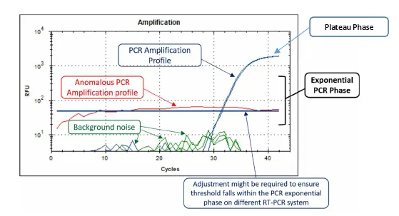
Source: Taken from Fortitude Kit 2.1 Instructions For Use
- Conduct Run Quality Control Analysis, as tabulated below:
**NOTE: The following requirements must be met within a single run. Otherwise, the run is invalid, and a re-test should be conducted.
Specimen | Cq Values |  |  | Interpretation
Specimen | 16S Gene (HEX) | mipT1 Gene (FAM) | Wzm Gene (Texas Red) | Interpretation
Negative Control | No Amplification | No Amplification | No Amplification | QC Passed
Positive Control | < 35 | < 35 | < 35 | QC Passed
Standard 1 (HEX) | <35 | No Amplification | No Amplification | QC Passed
Standard 2 (HEX) | <35 | No Amplification | No Amplification | QC Passed
Standard 3 (HEX) | <35 | No Amplification | No Amplification | QC Passed
Standard 4 (HEX) | <35 | No Amplification | No Amplification | QC Passed
Standard 1 (FAM) | No Amplification | <35 | No Amplification | QC Passed
Standard 2 (FAM) | No Amplification | <35 | No Amplification | QC Passed
Standard 3 (FAM) | No Amplification | <35 | No Amplification | QC Passed
Standard 4 (FAM) | No Amplification | <35 | No Amplification | QC Passed
Standard 1 (TEX) | No Amplification | No Amplification | <35 | QC Passed
Standard 2 (TEX) | No Amplification | No Amplification | <35 | QC Passed
Standard 3 (TEX) | No Amplification | No Amplification | <35 | QC Passed
Standard 4 (TEX) | No Amplification | No Amplification | <35 | QC Passed

- Export and transfer the each channel’s Quantification Data as shown below in figure 4 and transfer the data into the SOP Test Form’s “HEX_Raw_Data”, “FAM_Raw_Data”; and “TR_Raw_Data” respectively.
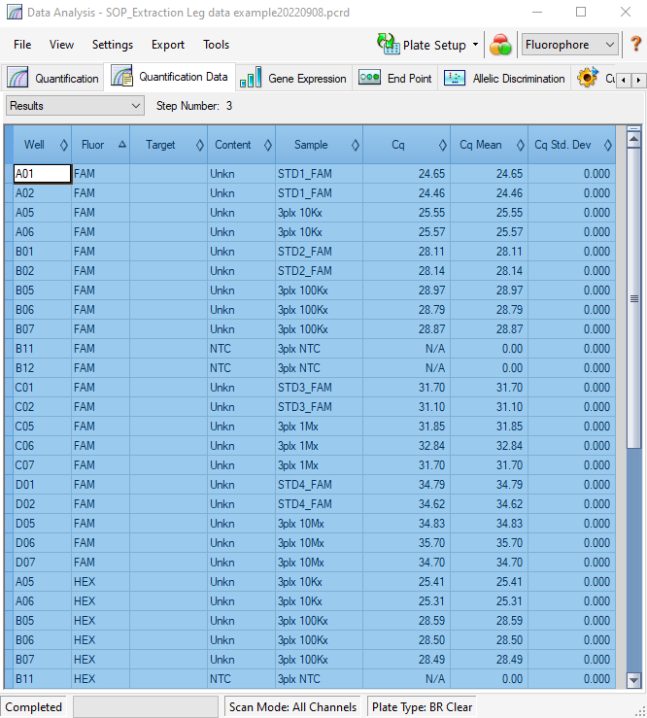
Figure 4. Quantification data of a PCR run file

- Verify that the individual channel’s quantification data are transferred correctly by ensuring that the data are situated at the correct columns position as shown in figure 5. The data will be extracted and analyzed in SOP Test Form’s “5) Standard”,”6) TestResult”, and “7) Report”.

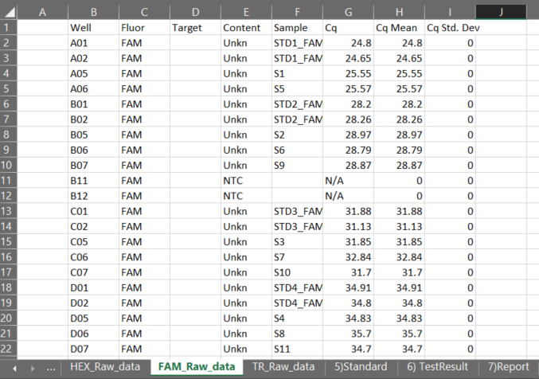
Figure 5. Example of quantifcation data is being transferred correctly for FAM channel.
- Standard curve equations are being calculated based on the known standard’s ct value detected within the run for each channel in the SOP Test Form’s “5)Standard”. The equation will be used for the calculation within the “6)TestResult” Sheet to estimate the amount of pathogen within the individual samples submitted.
- The Test Report can be generated by the SOP Test Form’s “7) Report” sheet based on the relevant information from the sheets within the SOP Test Form document. The necessary information reflected are 1) Client company name & address; 2) ESSF No.; 3) Received Date; 4)Processed Date; 5)Attention to; 7) Report No.; 8) Sample No.; 9) Batch No.; & 10) Sample Test Result(s).

- If any invalids are detected, a decision has to be made as soon as possible by the Laboratory Director. Immediately inform the Quality Officer/Laboratory Leader, and proceed to
  - Inform the Team Lead, and
  - update the Incident Log,
that a sample must be re-tested and prioritized in the next sample plate that will be loading. The Quality Officer/Laboratory Manager shall log this sample withdrawal in the Sample Database.

- Once the worksheet is completely filled, the operator shall inform the Quality Officer/Laboratory Leader (reviewer) that the data is ready for managerial review. If the worksheets are compliant, the reviewer will then submit the data to the Laboratory Director for approval. Any deviations to the test interpretation, which includes but is not limited to applying fluorescent drift correction, must be approved by the Laboratory Director.
- The Test Report will be authorized for released and validated by Team Leader.

- REVISION HISTORY

Revision Number | Revision Date | Revision Description | Requestor
01 |  | Initial Release

- APPENDIX

