Table of Contents
1.0 OBJECTIVE 2
2.0 SCOPE 2
3.0 RESPONSIBILITIES 2
3.1 Group Leader 2
3.2 Project Leader 2
3.3 Laboratory Room In-Charge/Key Owner 2
3.4 All Staff and Visitors 2
4.0 DEFINITIONS 3
5.0 REFERENCES 3
6.0 REAGENTS 3
7.0 CONSUMABLES 4
8.0 WORK SAFETY 4
9.0 TEST WORKFLOW and PROCEDURE 4
9.1 TEST REQUEST 5
9.2 Water Sample Collection Guidelines 7
9.3 Sample Send-off 8
10.0 REVISION HISTORY 10

- OBJECTIVE
This protocol describes the procedures for client companies to take note before submission of environmental water samples to CGD to assess the presence of Legionella. This protocol includes information on documents to submit and guidelines on how to take standard bulk water, and filter samples from commonly sampled sites. This protocol may be used in conjunction with the following documents:
- Environmental Sample Submission Form
- Shipment Packing List
- SCOPE
This document applies to Center for Genome Diagnostics under A*STAR, Genome Institute of Singapore and/or relevant client personnel.
- RESPONSIBILITIES
  - Group Leader
He/she shall ensure that all resources are available, staff is trained to the requirements stated before conducting laboratory work in the designated laboratories.
  - Project Leader
The Project Leader is responsible to coordinate and liaise all incoming and/or outgoing project related samples with third parties and ensure that the project team and visitors (if any) comply with the requirements stated in this document. He/She is the key contact person to monitor and record the usage of the samples. He/She should ensure that all operators are well trained and competent.
  - Laboratory Room In-Charge/Key Owner
The Laboratory Room In-Charge shall maintain storage facilities to the requirements stated in this document. He/She is also responsible to manage the Sample Storage Keys, and document required records accordingly.

  - All Staff and Visitors
It is the responsibility of all staff and visitors to follow requirements stated in this document. He/she is responsible for receiving and verifying all and only samples intended for his/her project team when required, notifying the Project Manager and/or Project Leader. They should perform experiments and data analysis based on the procedures stated in this SOP.

- DEFINITIONS

Term / Acronym | Description
A*STAR | Agency for Science, Technology and Research.
CGD | Centre for Genome Diagnostics
Consumable | Products that consumers use recurrently.
DNA | Deoxyribonucleic acid
ESSF | Environmental Sample Submission Form
GIS | Genome Institute of Singapore
ID | Identification/Identity
Material | Refers to reagents and consumables, equipment and biological samples that is required for its intended use for experiment.
PPE | Personnel Protective Equipment
SOP | Standard Operating Procedure
µL | Microliter

- REFERENCES
• SOP-TR1-QMS-003 Laboratory Workflow
• SOP-TR1-QMS-016 Sample Extraction and Quantification Guideline
• QR-TR1-QMS-014 F02 Sample Management Log
• QR-TR1-QMS-014 F03 Sample Tracking Checklist
• QR-TR1-QMS-014 F04 Sample Tracking Log
• QR-GIS-QMS-011 F01 Customer Satisfaction Form
• QR-GIS-QMS-011 F02 Customer Satisfaction Log
- QR-GIS-QMS-014 F02 Deviation Report

- QR-GIS-QMS-014 F04 Nonconformance Report

- QR-GIS-QMS-015 F01 Corrective Action Report

- QR-GIS-QMS-015 F02 Preventive Action Report

- Laboratory Biosafety Resources Related to SARS-CoV-2/COVID-19 Virus Samples/Materials, MOH, 20 Nov 2020

- Sampling Procedure and Potential Sampling Sites, CDC , Jun 2019

- Code of Practice For The Control Of Legionella Bacteria In Cooling Towers, IEE; MOE, 2001
- REAGENTS
Reagents | Components  (if any) | Company | Catalog Number
0.1N solution of sodium thiosulfate (Na₂S₂O₃) | NA | CGD/ GIS | Varies

- CONSUMABLES
Consumables | Company | Catalog Number
Pipette tips | ThermoFisher Scientific/Rainin | Various
Sterile Bottle/Bag | Corning/? | Various
Cooler
Ice Packs

- WORK SAFETY
All environmental samples are to be considered hazardous. The required PPE shall be dependent on the work performed in each venue, according to the table below:

Venue | Minimum PPE required | Types of work done
Collection Site | - Gloves  - Air-purifying respirator with an N95 filter* | Collection of samples
Sample preparation room, Level 5 | - Lab coat  - Gloves  - Safety Goggles  - 3-ply mask (Disposable) | Storage of Samples
Office | NA | Administrative work
* Wearing a half-face air-purifying respirator equipped with an N95 filter may be appropriate in the following situations: a.) when sampling cooling towers if the fans cannot be turned off, or b.) in enclosed spaces with an aerosol-generating device that cannot be turned off. Respirators must be used in accordance with a comprehensive respiratory protection program, which includes fit testing, training, and medical clearance.

During the handling of samples, there is still a risk that spills and splashes might occur. Any suspected work surfaces and equipment that come into contact with non-extracted environmental samples must be decontaminated immediately with appropriate disinfectants such as 70% ethanol solution.
- TEST WORKFLOW and PROCEDURE
The test workflow is shown below, and tracked with the worksheets:
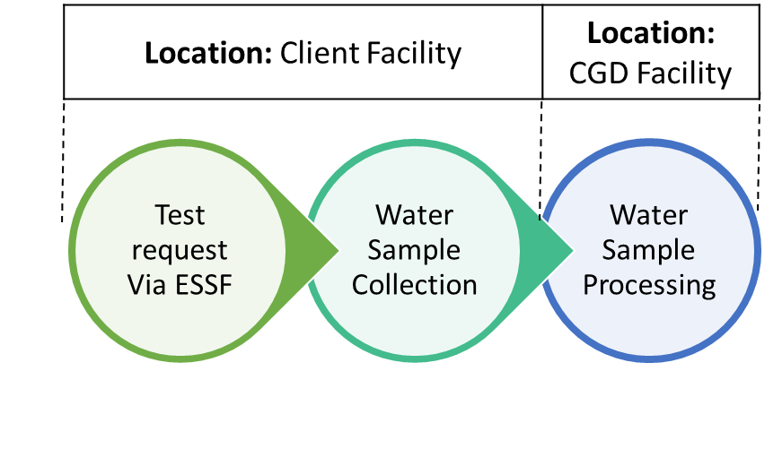
  - TEST REQUEST
The client company should submit a request for legionella water testing via the Environmental samples submission form (ESSF), clearly stating the sample ID for submission, type of water sample and required testing parameters.
Below is a representation of the ESSF:
Client Company is to fill in the necessary information for Sections A and B before submission to CGD for sample submission and processing. Upon CGD’s acknowledgement, arrangements can be made for sample receipt.

  - Water Sample Collection Guidelines
Environmental water sample collection is to be done by the client company before submission to CGD for testing. Sterile plastic bottles/bags may be provided by CGD upon request. In the event that the client company uses their own bottles, sterile bottles should be used to ensure accurate results. All samples should be transported to the laboratory in insulated coolers with ice packs as protection against extreme heat or cold. Samples that will not reach the laboratory within 72 hours should be refrigerated before shipping. Samples that reach the laboratory but cannot be processed within 72 hours of collection should be refrigerated.
    - Bulk Water Sampling
- For showers and faucets, facility maintenance personnel should remove the showerhead and the aerator respectively.

- Turn on the water and allow it to flow until warm not hot. Collecting heated water at 50° or higher will cause free-floating Legionella to die quickly.

- Collect 500ml of water into a sterile plastic bottle/bag while leaving an inch of headspace.

- Add ?ml of 0.1N Sodium thiosulfate solution into the water sample to neutralize residual disinfectants.
- Tighten the bottle/bag cap to prevent leaking.

- The bottles/bags should be labelled with an identifier and transported to CGD in a cooler with ice packs to ensure the temperature remains between 6 to 18°C on the same day.

      - Commonly sampled sites
The list below are examples of commonly sampled sites where Legionella may be present.
- Incoming water main
- Water tower that supplies water to the building
- Holding Tank
- Water Heater
  - Expansion tank of a heater
- Shower
- Faucet
- Whirlpool baths (i.e Jacuzzis)
  - Water in the tub
  - Water jets
  - Compensation tank
- Decorative fountains
- Sprinkler systems
- Safety showers/eye wash stations
    - Cooling Tower
An engineer or maintenance technician familiar with the facility should be engaged to identify the appropriate sampling sites of a cooling tower.
- Ensure that systems are operating and water is circulating through the system at least an hour before sample collection. Water samples should not be collected

  - near a make-up water inlet
  - If sediments are present and deliberately incorporated into the sample.
- Collect 500ml of water from the cooling tower pond into a sterile plastic bottle/bag while leaving an inch of headspace.

- Add ?ml of 0.1N Sodium thiosulfate solution into the water sample to neutralize residual disinfectants.

- Tighten the bottle/bag cap to prevent leaking.

- The bottles/bags should be labelled with an identifier and transported to CGD in a cooler with ice packs to ensure the temperature remains between 6 to 18°C on the same day.
      - Potential Sample Sites for Cooling Towers
The list below are examples of other potential sampling sites for Cooling Towers where Legionella may be present.
- Make-up water (water added to replace water loss because of evaporation, drift, or leakage)
- Collection basin (an area below the tower where cooled water is collected and directed to the sump)
- Sump (a depressed chamber contiguous to the basin, where water flows to facilitate pump suction; may also be used as collection point for silt and sludge)
- Storage tank or reservoir in the system
- Drift eliminators or other surfaces that remain moist
- Heat sources (e.g., chillers)

  - Sample Send-off
- Ensure the Environmental Sample Submission Form has been submitted to CGD before arranging the delivery of samples.

- Fill up Shipment Packing List and pack it together with the samples.

Below is the representation of the Shipment Packing List.
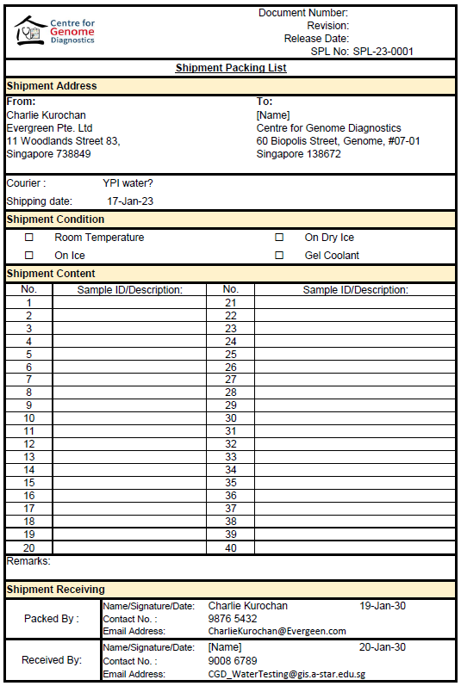

- Make arrangements for delivery with GIS Courier/ YPI Water.

- Delivery personnel will contact CGD Staff upon arrival to GIS Level 1 Lobby to hand over the samples. All relevant forms (e.g. Shipment packing list) and receipts will be used as proof of delivery.

- Upon arrival, the courier will be asked to sign and fill in a courier log after handing the water samples to CGD.
- REVISION HISTORY

Revision Number | Revision Date | Revision Description | Requestor
01 |  | Initial Release

